## Analysis Report

## CSYE 7374 Cognitive Computing and Deep Neural Network

Reference Link: <https://keras.io/scikit-learn-api/>

Data set used: <http://www.cs.utoronto.ca/~kriz/cifar.html>

**Part1: Implementing MLP for cifar 10 data set.**

* After building the base model with 2 layesr and batch size as 10 we get accuracy of .43
* Then we tune the model with different parameters and finally achieved accuracy of 51 percentage

|  |  |  |  |  |
| --- | --- | --- | --- | --- |
| Model | No of epochs | Batch size | Number of layers | Number of neurons in a layer |
| Base Model | 10 | 20 | 2 | 128,10 |
| Model 2 | 10 | 20 | 5 | 300,128,128,128,10 |
| Model 3 | 30 | 300 | 4 | 300,300,100,10 |
| Model 4 | 150 | 350 | 4 | 350,300,300,10 |

|  |  |  |  |  |  |
| --- | --- | --- | --- | --- | --- |
| Model | Learning rate | Activation functions | Dropout rates | loss value | Accuracy |
| Base Model | 0.0001 | Softmax and relu | N/A | 1.612 | 0.4353 |
| Model 2 | 0.0001 | Softmax and relu | 0.2 | 1.562 | 0.4508 |
| Model 3 | 0.0001 | Softmax and relu | 0.4 | 1.52 | 0.467 |
| Model 4 | 0.0001 | Softmax and relu | 0.4,.2 | 1.5 | 0.5157 |

**Part2: Implementing CNN on cifar 10 data set.**

* First load the data and run the base model
* Implemented scikit learn api grid search. Able to build a model and run the grid search only for the very small data set.
* If we implement grid search on the original data. We will get Resource utilizations error. So will not be able to implement the grid search for the entire data set.
* We get the important parameters like batchsize etc from the json file
* We are using random number generator to split the data

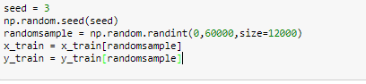

* We can get the summary of how many images per class we have in our sample

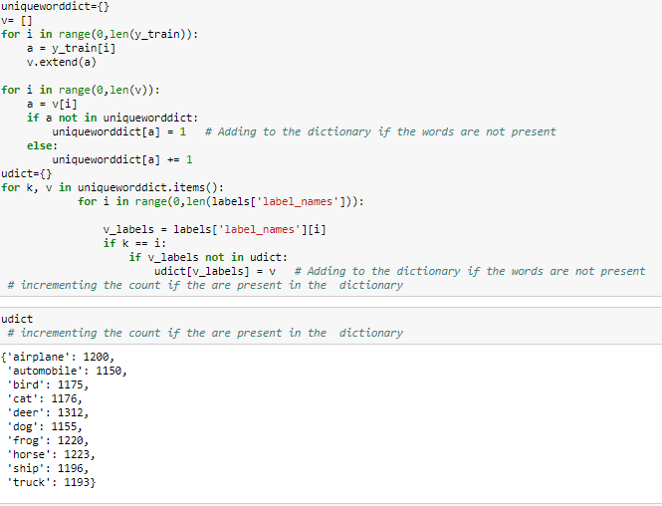

* With the base model we get the accuracy of .78 and when change few parameters for the new mode which is build for 12000 randomly selected image we are getting the accuracy as .58

|  |  |  |  |  |
| --- | --- | --- | --- | --- |
| Model | No of epochs | Batch size | Number of layers | Number of neurons in a layer |
| Base Model | 10 | 100 | 7 | 32,32,64,64,512,10 |
| New model (12000 image) | 10 | 100 | 7 | 32,53,64,120,512,10 |

|  |  |  |  |  |  |
| --- | --- | --- | --- | --- | --- |
| Model | Learning rate | Activation functions | Dropout rates | loss value | Accuracy |
| Base Model | 0.001 | Softmax and relu | 0.25,.5 | 0.69 | 0.76 |
| New model (12000 image) | 0.001 | Softmax and relu | 0.2,.5,.3 | 1.862 | 0.5808 |

Conclusion:

Since Grid search is taking lot of computational power, I am not able to run it for the complete dataset. I ran the code for only sample data set. As per the above model the best accuracy is obtained from based model only. We might need to tune the new build model for the randomly selected 12000 image .